Top of Form

Bottom of Form

JEN NORRIS DANCE REVIEWS



**Review: Deborah Slater Dance Theater presents In the Absence of Presence, Dance Mission, Nov 10-12**

Updated: 2 days ago

Deborah Slater Dance Theater’s (DSD*T) In the Absence of Presence*, a multidisciplinary collaboration, pairs many creative voices and performance practices to represent our scattered and unique experiences of the initial pandemic years.   The production conceived by collaborator Deborah Slater and culture curator and racial equity consultant Tammy Johnson, and directed by Slater seeks to respond to questions of resilience and perseverance in the face of both private and shared adversity.

Windows are projected onto the backdrop of the Dance Mission Theater. A steady patter of people speaking about their pandemic experiences can just be perceived through the hubbub of audience members chatting in their seats.  While the houselights are still up, Erin Yen, enters her curiosity and trepidation vying for supremacy as she directs her gaze up and around the room. Some of the audience pays attention, most do not, at least not at first, reminding me of how we each came to pay attention to the pandemic in our own time, many noticing too late.

The houselights remain on, additional people enter prompting a constant adjustment. Actors watch each other, make eye contact, decide who will yield while avoiding closeness at all costs and maintaining a “healthy distance.”

As the houselights dim, two groups of people distinguishable by their clothing are onstage. Group one, five DSDT dancers are dressed in show-ready costumes of gold chiffon hand-painted in greens and browns (Costume design Dana Kawano).  Eight members of the Cosmic Elders Theatre Ensemble wear bright white utility coveralls and medical masks.

The original jazz sax stylings of composer and musician Marcus Shelby welcome us to this new post-pandemic world.  The Elders circle each other, some moving clockwise, others counterclockwise, their masks having been removed and their hesitation lessened.  An orderly swirl of dashes moving in concentric circles (rumor has it the dashes are a death spiral of ants) is on the backdrop (Visuals Olivia Ting) echoing the onstage human patterns.

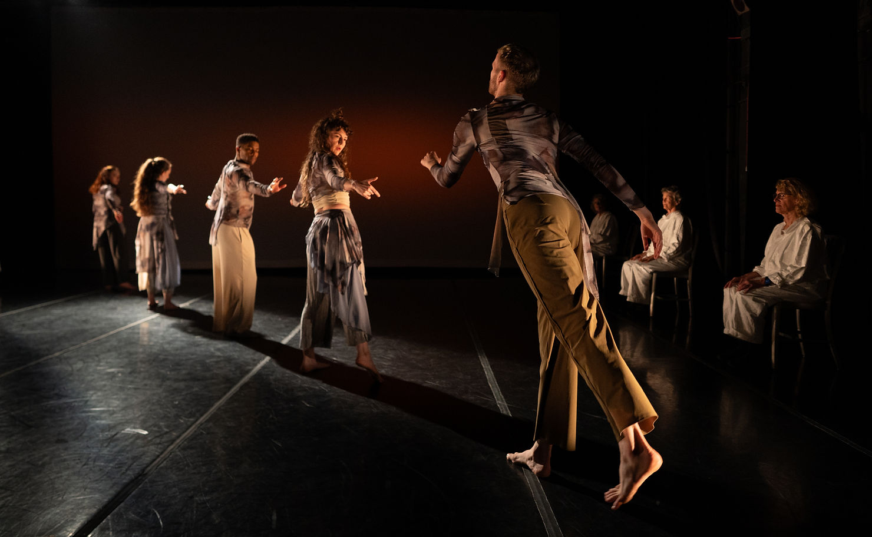

DSDT dancers create a diagonal in front of several seated Cosmic Elders; Photo: Robbie Sweeney

The Elders take seats lining the side of the stage, from which they will witness the proceedings.  Moscelyne ParkeHarrison swings a taut leg up parallel to the floor and arches dramatically over it to grasp it with both hands as if the leg is the barrel of a gun. She is joined one-by-one by DSDT’s dancers Colin Frederick, Anna Greenberg Gold, Calvin L. Thomas, Jr., and Yen, who each contribute a movement to a growing gestural phrase they craft together, along a lit diagonal.  After months confined to homes, taking class in their kitchens, stretching in a hallway and perhaps dancing outdoors they tentatively reenter the world of choreographed concert dance once more.

The text from interviews related to people’s lockdown experiences becomes the soundscape for several movement segments. The most memorable, entitled *Apartment,* finds Yen on an empty stage, feeling claustrophobic; her strides jut angularly as she navigates awkwardly around the imagined furnishing of the too small apartment of the narrator’s tale.  We are told that relief arrives in the form of the videogame “Animal Crossing.” Releasing the tension in her body, Yen sinks cross-legged to the floor; a glow on her face and torso suggests the screen in which she is now fully absorbed.  Embodying the fantasy world of the game, animal-masked figures cavort behind her.  Too much screen time, confined spaces, a fear of other people and the world outside is all recalled in this succinct and nightmarish scene.

Tempestuously, Greenberg Gold whirls and spins. Arcing through space she arches and draws a curved arm overhead.  Slinking backward, her body roils, until she is chased off by the women in white who rise from the edges, their chairs in hand.  These pure dance interludes, between spoken word elements, punctuate the intellectual with segments of heightened emotion.

Word for Word’s Patricia Silver stands center with the Cosmic Elders seated as a movement chorus behind her. Silver movingly recites a poem by Grace D’Anca. It is a reminiscence contrasting the empty pharmacy shelves of the early pandemic with those of a mom-and-pop pharmacy of old. The place one could buy a Russell Stover chocolate assortment and find a sympathetic ear.  The Elders sway slowly in their chairs, psychically contributing their own misty strands of memory to the poetry.  Images such as the candy box are distractingly projected on the back wall, drawing audible collective recognition from the audience.

ParkeHarrison lies, lounging sensuously. Sitting to spin quickly on her bottom, before rolling, arching upwards, she performs her evocative solo, *Pavement,* without ever rising to her feet.Her recorded voice recounts a night in June, when after five months of speaking only via screens, she reunites outdoors with a lover.  As the text concludes Frederick joins ParkeHarrison for a moonlit duet.  Beginning back-to-back in deep plie, their partnership grows as they mimic each other. Smiling, Frederick lifts ParkeHarrison to his shoulder where she shines on bended knee, as he spins. Savoring each moment, she departs too soon.

*In the Absence of Prescence* includes several excellent short dance films by DSDT performers, each working in collaboration with a Youth Speaks poet. *When Nanay Comes Home from the Hospital*tells the harrowing story of a Filipino nurse working long, crippling, fear-filled hours in a U.S. hospital during the pandemic.  Choreographer and performer Rachel Garcia physicalizes the story powerfully.  All pulsing energy, she contorts, grabbing her head and pushing here and there, the conflicting demands of too many patients and too few caregivers come to life.  The text asks “what it means to disappear,” as Garcia swipes her hands down her arms, wiping them clean and seeking affirmation of her solidity.

Kyle Limin dances with fluidity, grace, and power, well-matched to the rap of JWalt, in the brief film *Elevate*. The verses speak of being stuck in a cell and holding in the pain, while an oft-repeated phrase “we gonna elevate,” promises future relief.

Appearing in a gold-sequined cocktail dress and sparkly heels, Calvin Thomas, Jr. is the larger-than-life hostess of the satirical *Game Show*. For this “Lockdown Showdown,” Thomas welcomes us “Ladies, Gentlemen, Girlies, Gays and Thems.”  Prizes of homemade hand-sanitizer, ultra-valuable rolls of 2-ply TP, and a forged Vaccination card go to the audience member with the lucky ticket under their seat. Despite the best efforts of Thomas, and other sequined cast members, this skit falls flat, though it ends with Frederick’s throw-away zinger, “Isn’t it interesting how the same people always get the goodies?”

The contemporary dance portions, be they live or filmed, are strong, and I wish more dominant.  The second act concludes with an exciting series of solo and ensemble segments for the DSDT dancers, who each shine in their assignments.  A double duet featuring Thomas & Yen and Greenberg Gold & Frederick finds the women approaching from behind, to nest their heads beside their mates, luxuriating in the closeness. Moments of quarreling provide counterpoints to the deep falls into one another’s arms.

It is a difficult task to try to contextualize an event that has not yet concluded. We lack the necessary distance. The interviews, while heartfelt, fail to resonate, as we carry our own fresh history close to the surface. I am not ready to find humor in the failures of our infrastructure and the greed and selfishness of too many. While I nurture my appreciation for the dancers, the poets, the music maker and the creative team, the performance experience leaves me over saturated.

Review by Jen Norris, published November 18, 2023. Revised w. Production Credits 11/22/23

__________________________

Production Credits

Concept & Direction: Deborah Slater

Concept Collaborator: Tammy Johnson

Assistant Director: Lydia Feuerhelm-Chiu

Original Movement – created in collaboration with the dancers

PRODUCTION STAFF

Production/Stage Manager: Chi Chi Okonmah

Video Recording & Livestream Director: Jacob Marks

Camera Operators: Rachel Marks, Greg Meyers, Lindsay Gauthier

Livestream Moderator: Jessica Judd

PR/ Marketing: Liam Passmore

Assistant Sound Designer: Camille Rassweiler

Light Board Operator: Harry Rubeck

Sound Board Operator: Jabari Tawiah

PERFORMERS

Dancers: Colin Frederick, Rachel Garcia (film), Anna Greenberg Gold, Kyle Limin (film),

Moscelyne ParkeHarrison, Calvin L. Thomas, Jr., Erin Yen

Cosmic Elders +: Terri Cohn, Grace D’Anca, Mary Hones, Denise Larson, Beth MacLeod, Sybil Meyer, Patricia Silver, Courtney Stack

COLLABORATORS

Sound design: Cliff Caruthers

Original Music: Marcus Shelby

Costume Design: Dana Kawano

Lighting design: Allen Willner

Visuals: Olivia Ting

Original Movement: Colin Frederick, Rachel Garcia (film), Anna Greenberg Gold,

Kyle Limin (film), Moscelyne ParkeHarrison, Calvin L. Thomas, Jr., Erin Yen

Text includes community interviews, commissions from Youth Speaks, and writing by

the performers.

Community Interviewees: Pat Bashaw, Jabari Brown, Amber Butts, Omar Cardenas,

Tannia Esparza, Peggy Fong, Ruby J Fuala’au, Rachel Garcia, Weyam Ghadbian. Tammy Johnson, Jessica Judd, Kyle Limin, Eddie Madrill, Calder Acebo Morse, Sean Riley, Jai

Severson, Patricia Silver, Deborah Slater, Erin C Yen, Anonymous

©2022 by Jen Norris Dance Reviews. Proudly created with Wix.com